Greetings Ladies,
I have been doing some knitting. I have not been feeling well with a nasty flair up of Fibromyalgia since December along with issues with my neck and back. Sooo knitting goes is short spirts and doing smaller projects which I call knit therapy. Hats, hats and more hats are keeping me entertained. I like them because they are quick. I feel like I am accomplishing something. I have also been doing some spinning, a little weaving, lots of gardening and exercising. The gardens are doing great this year. It helps to move around and use different muscle groups.
These hats were practicing the patterns with fairisle. I was trying different patterns and getting them to fit in the hat design. These were all made with acrylic commercial yarns.
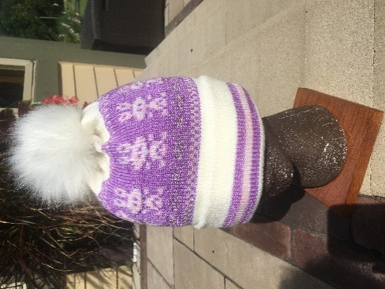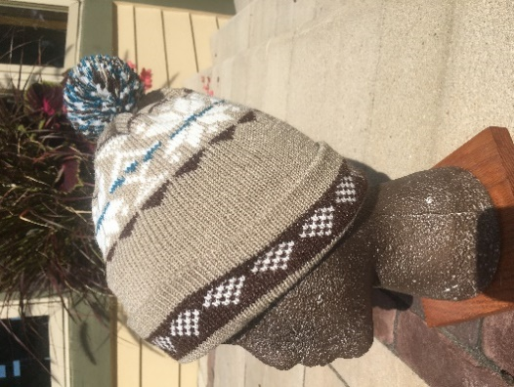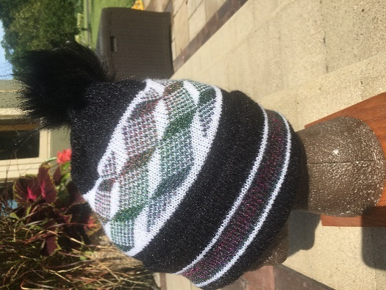

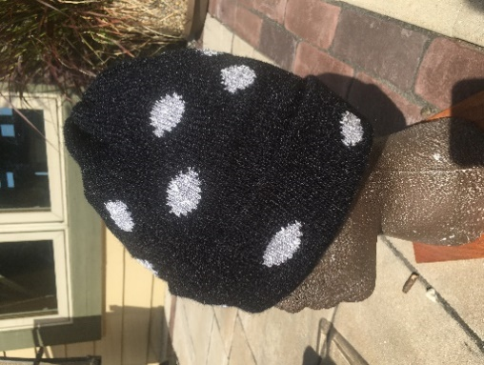 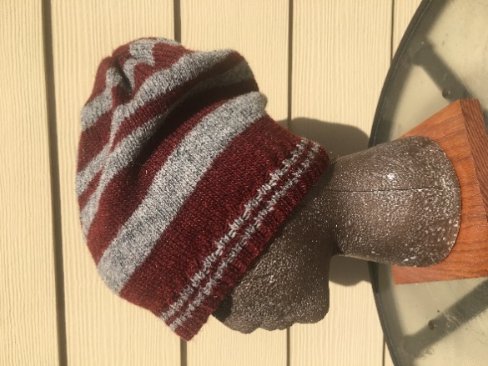 This hat is a different pattern 1X1 ribbing edge and basic stripe cap. This one is made with wool yarn.
These hats are handspun from natural fibers. This pattern was one that I saw in just about all Walmart stores last year. I took a picture of one of the hats and then figured out how to duplicate it.

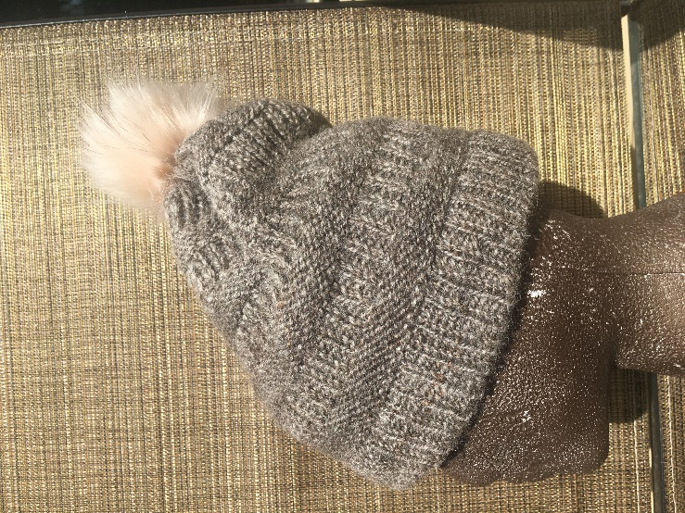
Fiber is Corriedale sheep wool that Peg so
generously gave me. I washed, picked, carded
and spun it. This is how it turned out. Very nice
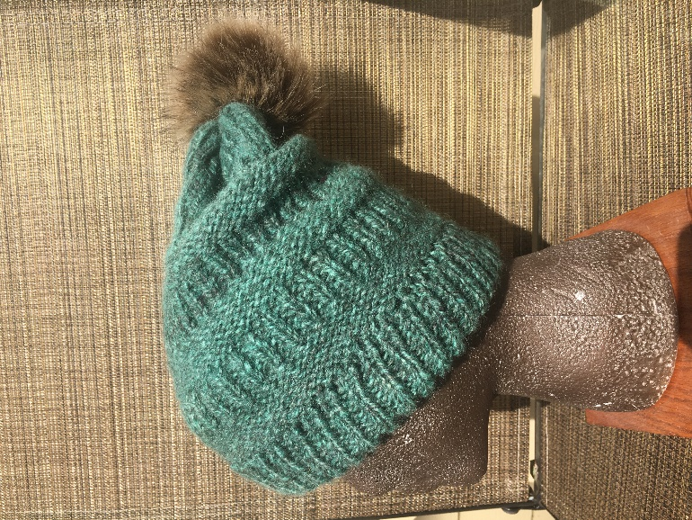 Same pattern but handspun from Merino sheep and Angora rabbit blend
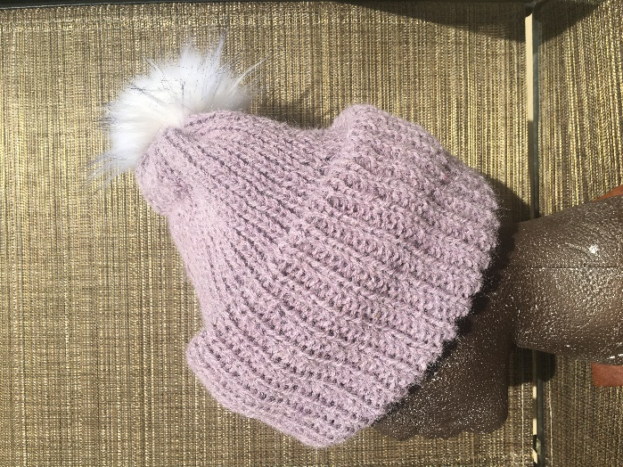 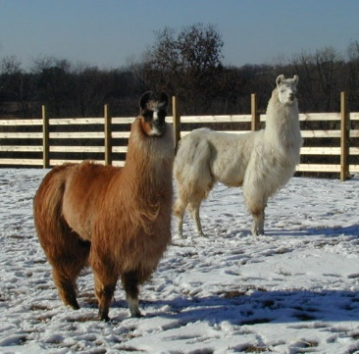 Flash and Excalibur
This is hand spun from my llama, Excalibur and dyed purple
This is not his natural color

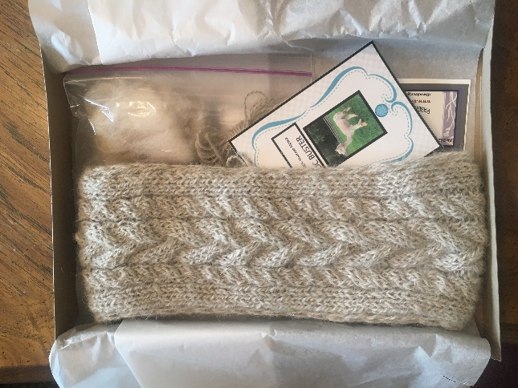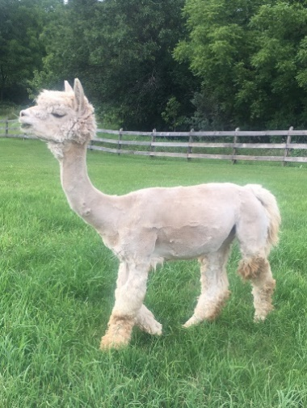
This is a head band I hand spun and knitted on my mid gauge using the Dragonpine designs Cozy Cables Headband pattern. I really like this pattern I made another one with my merino and angora rabbit yarn
This was made for my daughter to give a gift to one of her coworkers at Waukesha Hospital.
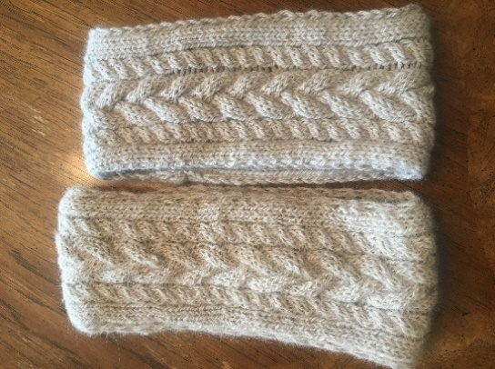 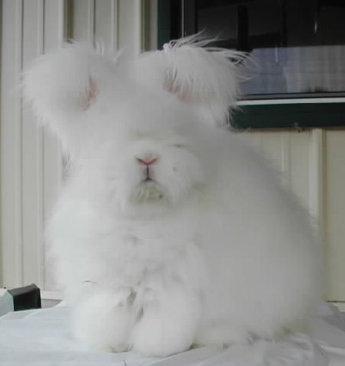 I am the butter part.
Alpaca on the left and angora /Merino on the right. The Angora, merino one feels like butter. My favorite
I also wove a scarf out of wool warp and acrylic weft stripes. I did this one on my ridged heddle loom.
